 | El pronóstico en Español  You are the meteorologist presenting the forecast on the “news”. Your task is to make a week long weather forecast for a specific location.  1. Needs to include:  a. 5 days of weather, including the date.  b. 4 different ways to describe the weather.  c. Suggested activities for 3 days based on the weather and location.  d. MUST submit a WRITTEN COPY.  3. Must be completely in Spanish  4. Must use known vocabulary (don't use translators!)  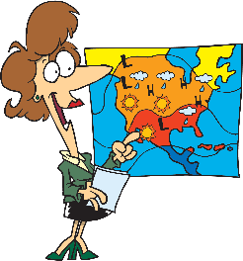  5. Visual aid may be a  a. Poster  b. Video  c. PowerPoint  d. Props |  | 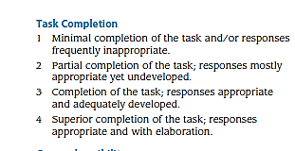
 |  |  | 